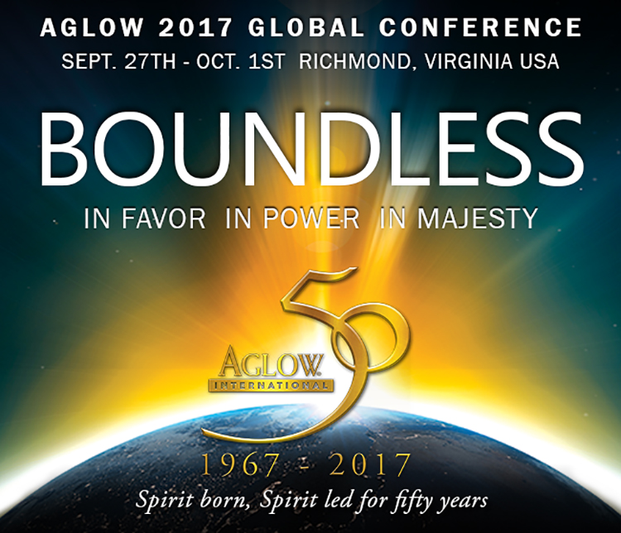
Contact Rick Allen  Telephone 425.275.0227  Email rickallen@aglow.org  Website aglow.org | FOR IMMEDIATE RELEASE  May 10, 2017

AGLOW INTERNATIONAL CELEBRATES 50 YEARS

Thousands will gather in Richmond Virginia to celebrate Aglow’s Jubilee Anniversary
Edmonds, WA, May 10, 2017– Aglow International will celebrate its 50th anniversary at their upcoming global conference in Richmond, VA, Sept. 27 – Oct. 1, 2017.
In 1967 from one city, in one state, in one nation the Holy Spirit began an incredible work in the lives of women that continues to this day in over 170 nations of the world. This fall, join with thousands of women and men from around the world as we gather to experience his boundless majesty and celebrate Aglow International’s jubilee anniversary.
– Jane Hansen Hoyt, President/CEO Aglow International
Speakers: Jane Hansen Hoyt, Dutch Sheets, Chuck Pierce, Barbara Yoder and Graham Cooke.
Aglow is a dynamic, Kingdom movement in over 170 nations of the world made up of women and men with a single purpose: to see God's will be done on earth as it is in Heaven.
# # #
If you would like more information about this event, please contact Rick Allen at 425.275.0227 or email at rickallen@aglow.org.

