**FINANCIAL DIGEST**

**RECENT CHANGES**

The process to update the whole Digest is huge and takes time. The date on the following Digest does not mean the entire Digest is updated.

NOTE**:** This Digest is being gradually updated. The following pages are the only pages you need to print to replace and update your current digest.

**2021**

* Page 8: Aglow contact Christie Spaulding - [ChristieSpaudling@aglow.org](mailto:ChristieSpaudling@aglow.org)
* Page 13: Insurance Carrier contact updated
* Page 9: 990N – ePostcards filing to be done by Headquarters

**2019**

* Page 27-29: FAQs updated
* Page 13: Insurance carrier contact information updated 8-13-19

**2018**

* Page 25: If your offerings are less than $50,000 annually, Headquarters will file all 990-N e-Postcards. If your offerings are more than $50,000 call the Global Field Office – U.S.A. at Headquarters
* Page 13: Replace nancy@mcdonaldins.com with patty@mcdonaldins.com

**2017**

* FILING TAXES: The 990-N e-Postcard Package – Please do NOT file your own 990N postcard. If you receive correspondence from the IRS please forward it to Aglow International, Global Field Office, U.S.A.
* EXPENSES AND GIVING: Tithes & Offering – Area Teams tithe 3% to Regional Directors; Lighthouses tithe 2% to Regional Directors. Round up to a minimum of $5.

**2014**

* Page 2: As of Jan 1, 2014, Lighthouse bank accounts need to add an Area officer as a signatory on their bank account.

The following Digest includes the updates. We suggest that you print the recent updates for comparison with someone who has an older version. If you have any questions, contact Christie at [ChristieSpaudling@aglow.org](mailto:ChristieSpaudling@aglow.org)



Financial

Digest

A financial guide for

Area & Lighthouse Vice-Presidents

of Financial Development

Table of Contents

INTRODUCTION 7

Job Description 7

Opening a Bank Account 7

Setting up the Account 8

Other Uses for Your EIN 9

REVENUE 10

Offerings 10

Various Kinds of Restricted Offerings 10

Depositing the Revenue 11

EXPENSES AND GIVING 12

Tithes & Offerings 12

Insurance 12

Contracts and Proof of Insurance 13

Other Expenses 14

ACCOUNTING FOR REVENUE AND EXPENSES 15

Accounting for Revenue 15

Accounting for Expenses 15

MONTHLY DUTIES 17

The Aglow Monthly Meeting 17

Aglow Leadership Team Meeting 17

Other Responsibilities 19

Balancing the Bank Account 19

ANNUAL DUTIES 21

The Annual Financial Report 21

FILING TAXES 23

1099-Miscellaneous Form 23

Form 1096 24

Information on Tax Reporting 24

Who Needs to File a 990-N e-Postcard? 25

The 990-N e-Postcard Package 25

Budgeting and Planning for the New Year 25

Accounting Software 26

FAQs 27

FORMS / MASTERS / SAMPLES 30

Attention Filers of Form 1099-Misc: 31

Attention filers of Form 1096: 32

# INTRODUCTION

Welcome to the world of finance management for the Aglow International ministry. The highest use for money is to advance God’s kingdom...in your community, in your area, in your region, and around the world. You will play a crucial part in the success of your Lighthouse or Area Leadership Team as you help to manage your team’s Aglow resources.

Ministry always requires resources and resources require managers. If your Aglow is to continue reaching people for Jesus, you need funds to operate. You also need a careful, trustworthy manager to help oversee them. That is, you!

We realize at times your ministry may seem hidden. Remember, the work of your hands is like a prayer to God. As Vice President of Financial Development, be confident that God treasures you and your service to Him. You are His trusted steward. Through your integrity, diligence and faithfulness lives will be transformed and God’s kingdom will grow.

Job Description

This is an overview of the duties and responsibilities of a Vice President of Financial Development. (For a full description see the *Leader’s Digest.)*

* Manage all ministry funds both incoming (revenue) and outgoing (expenses) in accordance with your team’s decisions.
* Balance monthly bank statements and prepare brief financial report to be presented at your monthly Leadership Team meetings. The bank statement should go to the President of your team. However, if this is not feasible because of proximity to the President, you should bring the statement to your team meetings so that the President (and any other team member) may look it over. This is a level of accountability.
* Prepare and track all speaker/teacher reimbursements and honorariums, Leadership Team expenses, and all tithes and offerings to Global Headquarters, as decided by the team.
* Prepare annual financial reports. Area Teams send them to Global Headquarters and to your U.S. Regional Director. Lighthouse Teams send them to your Area Team. Forms should be completed and sent to the appropriate team by January 31 of each year.

Opening a Bank Account

Feel free to use any bank or credit union that is convenient for you. However, note that some banks do not charge service fees for non-profit organizations, and some do.

Prior to going to the bank, make sure you have:

* The IRS letter (Form SS4) issued specifically to your Lighthouse/Area Team that gives your EIN (Employer Identification Number). **This will come in a folder to the President if you are newly affiliated; do not apply for one yourself.**
* A copy of this letter should also be given to the VP of Financial Development. This letter should be transferred to the next person filling either of these positions.
* It is very important you give the bank the EIN issued specifically to your Lighthouse/Area Team, and not the one issued to the Global Headquarters of Aglow International.
* Once you decide on the bank you want to use, please contact [ChristieSpaudling@aglow.org](mailto:ChristieSpaudling@aglow.org) and she will send a copy of the Letter of Determination issued to the Global Headquarters by the IRS. She will also send any other information requested by the bank.
* Christie will need the email or fax number of the person at the bank who is helping you set up the account.

Setting up the Account

Many banks are requiring that Aglow International be the mainline on the account. If this is required by the bank you choose, that will be okay. However, you must ask that your Lighthouse or Area name be the second line on the account along with your Aglow ID#. **If the bank will not do this, please call the U.S. Department at Aglow Headquarters BEFORE completing the account.**

* You will need 3 signers on the account: the VP Finance, the President and one other officer.
* **NEW since April 2013 –** Aglow also requires that an Area team member be a signer on the Lighthouse account. This person will not be signing your checks, but will have access to the account on the rare occasion when this becomes necessary.
  + Area teams are to have their Regional Director on the account for the same reason.
  + **This is a step of accountability required by our auditors**.
* Aglow guidelines require two signatures on checks. Most banks do not care about this. Whether you have one or two signature lines on the check, two people still need to sign the check. Just let the bank know that this is the procedure you will need to follow.
* **We suggest you print only the name and identification number, and not the address on your checks**. That way, if you have a change in officers you can still use the same checks and change only the address your statements are sent to.
* Also, be sure to order a book of duplicate deposit slips. The ones that come standard with the checks are not the duplicate kind. This will assist you in keeping your records, and will give you an ample supply.

NOTE: Receipts for tithes, donations and other funds sent to headquarters will be mailed to the President rather than the VP of Financial Development as another accountability practice.

It is NOT recommended that the President also be the V.P. of Financial Development. While this cannot be avoided sometimes, this should only be for a very short time. It is recommended that a different person on the team take on these duties until a person can be found to take this position.

Other Uses for Your EIN

* If you want to set up a bulk mail account, the U.S. Postal Service will require your EIN. Providing the post office with this information enables them to issue a permit that allows you to mail at the reduced rates available to non-profits.
* **DO NOT file a 990N – ePostcard for your Lighthouse.** Headquarters is now filing all 990’s for the Lighthouses and Area teams. If your offerings are more than $50,000 call the Global Field Office – U.S. Headquarters.
* If you want a state sales tax exemption, you need to obtain this from your State Department of Revenue. They would also need your EIN. State Sales tax exemption is a **state** issue and not an IRS issue.

# REVENUE

Revenue is all money coming into your Aglow through offerings, tithes, gifts, publication sales, or fundraising projects.

Aglow has been granted tax-exempt status provided that money received from donors is used for the ministry purposes stated in our Constitution and Bylaws. Aglow funds are **never** to be used for personal gain or to benefit an individual.

Offerings

You or anyone on the Leadership Team is approved to receive an offering. You, as the Vice-president of Financial Development, are responsible for counting the offering **along with another person** from your leadership team to insure accuracy. (More about this under *Monthly Duties*.)

General fund offerings are used to operate your monthly meetings and can be used for a variety of projects or needs that your Aglow is working on or involved with. Designated offerings, however, must be used for the purpose for which they were collected. Designated offerings are kept separate on your ledger sheet under restricted. Restricted meaning that they have been designated for a specific use.

Various Kinds of Restricted Offerings

There are a variety of reasons why a designated (or restricted) offering may be taken. Following are some important guidelines for designated (or restricted) offerings:

* Aglow Headquarters has asked for a donation for specific event or program – you collect the funds and they would be designated for HQ and listed on your ledger as restricted for HQ.
* You plan on an outreach into your community and you take special offerings for that. Those funds are restricted for the outreach in your ledger. Any money spent for the event is subtracted as an expense from that restricted fund.
* Perhaps you set up a fund to help send your Leadership to Conference or Regional Events. You might take an offering for this. You also may decide to set aside some of your general funds for this and “move” that amount to a restricted fund called Conferences. This is a legitimate expense for your team because these are leader training events and is important for vision casting for the Leadership team of the group.
* Your team may decide to have a benevolence fund and take a designated offering for this. This kind of giving is used to occasionally minister directly to someone in your group who has an emergency need. You may decide to give groceries, pay their electric bill, etc. However, this should not be the same person all the time. If you have questions about this fund please call U.S. Department at Aglow Headquarters.
* When receiving a designating offering it is always good to say that *if we receive more funds than are needed for the event (or whatever it is) those funds will be moved to our general fund.* This releases you from having monies you can use sitting in a restricted fund or having to go back to the donors to get permission to remove it from Restricted.

IMPORTANT: **You should *not* give money to other ministries no matter how worthy the cause.** You may help support a local organization by collecting and giving items, (i.e., diapers and baby supplies) to a local pregnancy center.

Also, it is illegal, according to the IRS, to give money to officers on the Leadership Team or their relatives. This constitutes what is called Private Inurement. The legal definition of Private Inurement is, “When funds, or other items, are used for the personal benefit of the organizers, leaders, or administrators of a tax exempt organization.”

When receiving offerings for other special projects, ensure that the purpose of the offering is connected to Aglow’s Vision Statement: t**o carry the truth of the Kingdom that restores people to a radiant place of relationship with God and one another; breaks the tyranny of oppression; brings freedom and empowerment.**

Offerings taken for your general fund provide the most flexibility to meet the needs of your Aglow.

Depositing the Revenue

After each fundraiser or monthly meeting, it is essential that all money received be deposited into your Aglow bank account. After depositing, record the amount of the bank deposit on your Bank Ledger (see Page 16). For more details related to depositing, see the section entitled *Monthly Duties*.

# EXPENSES AND GIVING

The definition of expenses are funds paid by your Aglow for things such as rent for your meeting place, refreshments for meetings, publicity, speakers. Expenses may also be incurred when you give money to the Global Headquarters in the form of tithes, love gifts, and pledges.

Your Leadership Team is asked to give on a regular basis to bless and help support the other ministry levels of Aglow. The following is the minimum that should be given and how often:

Tithes & Offerings

* To Aglow’s Global Headquarters. Lighthouses and Area Leadership Teams tithe 10% of their unrestricted income on a monthly basis. We strongly suggest that you round up your tithe to a minimum of $5.
  + In addition, offerings above the tithe should be sent to Global Headquarters to help support the work of Aglow around the world.
  + Each team is encouraged to become a member of “A Company” by agreeing to send a minimum of $10/month to Headquarters.
  + The receipt will be sent to the Lighthouse President, rather than the Vice-president of Financial Development. This is at the request of our auditors, who want us to have a system of checks and balances.
* To U.S. Regional Directors. Lighthouses send 2% and Area Leadership Teams send 3% on a monthly basis to Global Headquarters. Again, we strongly suggest you round up your tithe to a minimum of $5.
* To State Prayer Coordinators. Send an annual love gift (or more often) to SPC if she has her own Aglow bank account or to her closest Area Team that handles her funds. This is usually done in May.
* To Area Leadership Teams. Regular love gifts from the Lighthouses. Send direct to Area Leadership Team.

Insurance

Aglow International pays an annual premium for insurance that covers your Aglow activities. In the first quarter of each year, Global Headquarters sends out a letter asking each Area Leadership Team to pay their portion of the premium by sending in their contribution.

Since 2000, we have asked the Area Teams to send in the full insurance contribution, and have instructed them either to have each Lighthouse send them a portion of the insurance fee or take up a special offering to reimburse their treasury.

By contributing in this way, you help give your Aglow the following insurance coverage:

* Children in an Aglow-sponsored childcare.
* Any Aglow volunteer or guest at an Aglow sponsored event.
* Rented property, such as sound equipment or projectors.
* Meeting room or building damage that might be due to Aglow activity.

Contracts and Proof of Insurance

When your meeting facility wants a “Certificate of Liability,” (proof of Insurance) you can call or email our insurance carrier. They will provide the documentation you need to secure your meeting or retreat (for Area Teams) space.

The insurance company needs the following information in order to issue a certificate (proof of insurance) for an event:

* Name of organization where your event is being held
* Contact name and email address for organization
* Address of event
* Fax number where the insurance company can send the certificate
* Dates of the event
* If this is a recurring event, how often the event will occur or when the next event will happen.
* **If you are being asked to sign a contract, send a copy of the unsigned contract for approval.**
* **DO NOT SIGN A CONTRACT UNTIL IT HAS BEEN APPROVED BY OUR INSURANCE COMPANY.**
* **WE DO NOT SIGN CONTRACTS WITH HOLD HARMLESS CLAUSES!**

Our insurance company is:

**The Partners Group *(McDonald Ins. Group Inc.)***

**Aglow Account Manager:** Molly Benshoof [MBenshoof@tpgrp.com](mailto:MBenshoof@tpgrp.com)  
**Direct Line:** 425-897-5026  
**Toll Free:** 1-877-455-5640  
**Main:** 425-897-5962  
**Fax:** 425-455-6727

11225 SE 6th St. Suite 110,   
Bellevue, WA 98004

Office Hours: Monday – Friday 8:00 a.m. to 4:30 p.m. (Pacific Time) Closed Weekends and most Federal Holidays

If you need more information or need to file a claim, an insurance agent will be happy to help you and provide you with the forms you need.

Note of clarification.Aglow pays claims when Aglow is responsible for the injury or damage. For instance, if someone is injured due to a safety issue with your meeting place such as a pothole in the parking lot, the rental place is liable since it is their responsibility to keep the parking lot in good repair. If however, someone trips over a cord that was used for your overhead projector, then our insurance would cover any injury to that person up to $10,000 per person, per accident. **(Contact our insurance company for a claim form.)**

Other Expenses

If you have paid a speaker more than $600 in one year, it is important to obtain their tax information: Either their social security number or tax I.D. number if they have a business or ministry. This is very important since you will be issuing a 1099-Misc. at year end (see Page 23). There are example forms in the forms section.

Other expenses you might incur are things such as rent for your meeting place, mileage, supplies, postage, and honorariums. Account for any of these expenses on the bank ledger sheet as follows:

One of the expenses you may be asked to pay is mileage. The question of mileage reimbursement is the number one question asked at the Global Headquarters office from the field. **You should reimburse speakers who speak at your Aglow for mileage at the business rate, as set annually by the IRS.** The mileage rate varies from year to year. Check the IRS Web site, www.irs.gov, after each new calendar year for the new IRS official mileage reimbursement.

For Aglow leaders and volunteers, mileage shouldbe reimbursed at the volunteer rate, also set annually by the IRS. Aglow Leadership Teams can decide if their group desires to or can afford to reimburse volunteers’ mileage. If the Leadership Team decides not to reimburse, the volunteer is still free to claim mileage on their U.S. tax return, if they itemizes deductions. Note: The volunteer rate would not apply to speakers or U.S. Regional Directors. They would be reimbursed at the business rate.

The Ledger on Page 16 is set up to correspond wit the Annual Financial Report that is due on January 31st of each year. Feel free to add columns as you need them. You may keep your records in a ledger book, in Excel, or in another accounting program on the computer.

# ACCOUNTING FOR REVENUE AND EXPENSES

The Bank Ledger Sheet can be found online under the Financial Digest Forms/Masters/Samples. A Sample of a completed ledger sheet is on Page 16. Lighthouses will most likely not use the Restricted/Designated area as often as Area Teams.

Accounting for Revenue

For example:

* Offerings & Donations – input amount under Deposit column and Offering column under the Revenue/Income (Sample $150).
* Fees for luncheon – input amount under Deposit column and Fees column under Revenue/Income (Sample $175).
* All income, whether in the form of offering, donations, fees, or sales, all income is placed both in the Checking area, Deposit column for balancing your check book, and under the appropriate column in the Revenue/Income area. Designated offerings are listed as a deposit and then under Restricted Funds column.

Accounting for Expenses

For example:

* Sending tithes to Aglow HQ – record the check number and the amount paid in the corresponding columns, under the Checking area; record the amount in the appropriate columns in the Expenses area (Sample – Tithe = Check #1407, for $10).
  + Remember to round up your tithe. Make it a minimum of $5 (*you can’t out give God!*).
* Purchases – record the check number and the amount paid in the corresponding columns, under the Checking area; then, record the amount in the appropriate columns in the Expenses area (Sample – Print/Postage = Check #1408, for $25).
* All checks written to pay any expense are recorded by check number and amount in both the Checking and Expenses areas.

On the following page is a sample of how to use the Bank Ledger Sheet. You can find the form online at [www.myaglow.org](http://www.myaglow.org). Follow the links: My Recourses > Leader’s Resources USA > Financial Digest > Forms/Masters/Samples > Bank Ledger Sheet (both Excel and PDF formats). From there you can download and use in Excel or print the PDF form to record by hand.

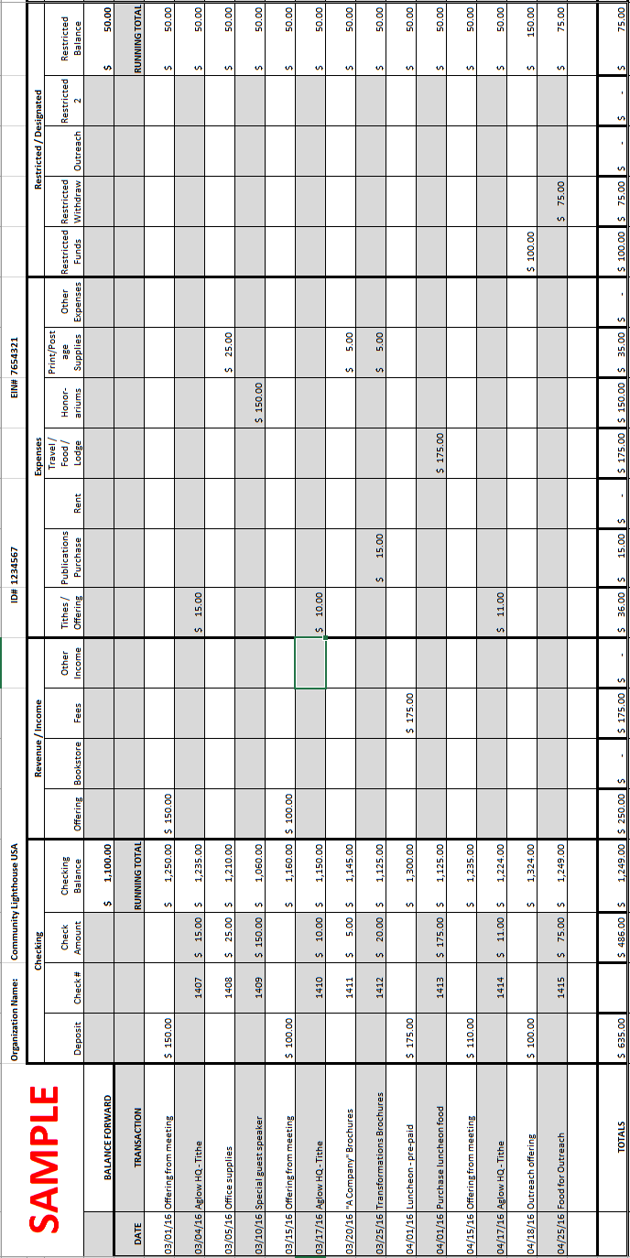

# MONTHLY DUTIES

In this chapter we will look at duties as they relate to your Aglow meeting, your Aglow Leadership Team meeting, and other Aglow responsibilities fulfilled after meetings from your home.

The Aglow Monthly Meeting

At your monthly outreach meeting you may receive money for a variety of reasons such as, offerings, donations, sales, fees for retreats or meals, and etcetera. The following is an overview of an easy way to sort and count the money, making sure to keep money received for different reasons separate. Remember to have two team members counting the funds. (See *Counting Form* in *Forms/Masters.*)

* Separate checks and cash.
* Be sure to note the memo line of check to see if it marked as a designated offering. If it is, separate these checks.
* Separate bills and coins into like denominations ($10 dollar bills in one pile, quarters in another, etc.)
* Count each type of currency at least twice for accuracy.
* Add totals for each denomination together.
* Add the check amounts; run two tapes. Endorse checks on back with bank deposit stamp.*
* Add checks, currency, and coin together for final total.
* Both team members should verify, by signature, the final total.
* It is a good idea to count your designated offering separately and make a separate deposit. It helps keep your records clearer. Mark on the deposit slip what the designated offering is for.

*The back of each check should say “For deposit only,” your Aglow name, and account number. Purchasing an endorsement stamp can help make endorsing your checks easier. If you don’t wish to order a stamp, simply write these on each check.

Aglow Leadership Team Meeting

**A very important part of your responsibilities each month is to bring a financial report to your Leadership Team meeting.** Some Area Teams may also require you complete a Lighthouse Monthly Financial Report with the Lighthouse Ministry Update (Minutes).

* It is crucial that all the members of the Leadership Team have a clear financial picture of your Aglow.
* You will want to communicate how much money came in for the month, such as offerings, sales, etc.
* You will also want to have a detailed list of expenses that were paid for the month, as well as what the ending balances are on the bank accounts (checking [general fund and restricted funds] and savings, if you have one).
* It is also important to let your Leadership Team know of any large expenditure that may be coming up, such as (for Area teams) a deposit on a retreat center.

Following is an example of how a report could look for your meeting. Don’t worry about how it looks exactly, just as long as all the information is represented.

**Seattle WA Community Lighthouse**

**Monthly Financial Report**

**June 2002**

Prior Month Ending Bank Balance $257.25

Income $124.00

Total (amount in checkbook) $381.25

Expenses

Facility Rental-Holiday Inn $ 50.00

Honorarium-Guest Speaker $100.00

Food-Costco $ 15.00

Total Expenses $165.00

Ending Bank Balance total in check book – expenses $216.25

Balance in Savings $110.00

Other Responsibilities

Depositing your funds is quick and easy. You and one other person have already counted and verified how much money you received – use the *Counting Form* to assist you in filling out the deposit slip. Just list your coin, cash, and checks on your duplicate-deposit slips. Take both copies with the funds to the bank. They will process your deposit slip and give one copy back to you for your records. File the deposit slip copy and the *Counting Form* with the bank statements. Set up folders for each month to keep all information related to that month in the same folder. Include income received as well as receipts for expenses paid.

Balancing the Bank Account

Bank reconciliation is a very important monthly duty as part of your role as the finance manager of your Aglow.

* Your bank statement comes with a form to help you reconcile your account.
* There is also a *Bank Reconciliation Form* under *Forms/Masters.*
* You can also make a spreadsheet in Excel you can reuse every month that will automatically calculate your ending balance for you.
* If you work in Excel there is a form that you can download from the web or have sent to you from the U.S. Department at HQ which has all the formulas in place for reconciling your bank statement.
* If you use an accounting program, it will have a way to balance your statement.
* Please feel free to use whatever works best for you. Gather the bank statement for the month and the corresponding ledger sheet along with any cancelled checks you received from the bank. The important thing is that you do this monthly.

The First Step to Balance your statement

* Find the ending balance on the bank statement.
* Identify what checks have cleared.
* Calculate the total amount of outstanding checks (checks that have not cleared the bank.)
* Confirm that all your deposits are recorded on your statement.
* A deposit not recorded by the bank is called a “deposit in transit.”
* Fill in the reconciliation form with the bank balance, outstanding checks and any deposits in transit.
* The bank balance minus the outstanding checks, plus deposits in transit equals the “adjusted bank balance.”

The Second Step: The Ledger balance

* This number is the ending balance for the month in your “Bank” section of your ledger sheet.
* Verify that you have calculated correctly for the month and put this figure in the “balance per books” section of the form.

The Third Step: Make adjustments

* Adjust for any bank charges or interest.
* If you recorded a check or deposit wrong make the adjustment.
* After you have accounted for all the adjustments, complete the reconciliation form by adding or subtracting these adjustments. This will give you the “adjusted book balance.”

The Fourth & Final Step: Compare the Book to the Bank

* If all has gone well, your ending bank balance from the bank should match your “adjusted book balance.”
* If they don’t match, take a break for awhile and try it again or have someone else check your figures.
* If it still doesn’t balance and it is a small amount of money, enter the amount as an “unreconciled difference” on the bank reconciliation form and move on. In later months you may be able to identify this amount; but even if you aren’t able to, don’t worry, just keep going and give yourself grace.
* File this form in your monthly folders with the bank statements.

# ANNUAL DUTIES

In this chapter we are going to look at a variety of things related to your duties that happen only once a year.

The Annual Financial Report

Each Area and Lighthouse needs to complete an Annual Financial Report.

* If you are a Lighthouse Vice-President of Financial Development, you will need to send your report to the Area Leadership Team by January 15th of each year.
* If you are the Area Vice-president of Financial Development, you will need to send your report to the Global Headquarters, attention Executive Director U.S. Field, by January 31st of each year.
* Send a copy to your U.S. Regional Director.

Accountability is important and Paul reminds us in II Corinthians 8:21, when we are dealing with money we should be honorable with things, “not only in the sight of the Lord, but also in the sight of men.”

The Annual Financial Report is located in the *Forms/Masters* section. You can also download an updated form from the web or ask the U.S. Department at HQ to send you one. The updated form will automatically do the math for you. Gather your ledger sheets, as the Financial Report is connected to the ledger sheets. Fill in the top portion of the report with your Aglow name and other important information.

Now, let’s take each section one at a time.

Income

* *Offerings* are monies you received as a gift or donation to your Aglow.
* *Sales* are monies for books or craft items you sold to generate income.
* *Registrations* are monies collected for a specific purpose, such as a retreat (for Area Teams) or funds you collect at the door for food, as an example, at your monthly meeting.
* *Other* could be money received for sales tax or interest income from the bank.
* Add all your income and record that number on the Total Income line.

Expenses

* Tithes/Donations are money given to the Global Headquarters, Area Team, U.S. Regional Director, SPC, or other. This is also where you record any benevolent giving during the past year.
* Publication Purchases are money spent for books and other products you buy for the purposes of selling.
* Rent/Meals are funds you pay out that were collected for a meal or rent paid on the meeting space.
* Travel/food/lodging is money reimbursed for a speaker’s hotel or airfare costs, or for example, your President’s conference expenses.
* Honorariums are money given to a speaker, a worship leader or person for special music.
* Printing/postage/supplies/phone is money paid for these particular expenses.
* Other could be for sales tax or bank fees.
* Add all your expenses and record that amount on the Total Expenses line.

Net Income for Period

Net income is your income less the expenses. This number indicates if your Aglow has brought in more money than you have spent.

Other Transactions

* *Restricted donation* is money given for a specific purpose. That money must not be spent on anything other than for what the donor gave.
* *Sales tax due* indicates how much of the remaining money is allocated to be paid out for state taxes on items sold.
* *Balance forward in bank account* is the ending balance last year.
* *Ending cash balance* is the amount that is in all bank accounts on December 31st of each year.
* Sign and date the report and put it in the mail, or send it via e-mail – type your name on the signature line and put by email in parenthesis.

# FILING TAXES

1099-Miscellaneous Form

(See a SAMPLE of a completed form on Page 33)

A 1099-Miscellaneous form is used by a person or business to report payments made to another person or business who is not an employee. The form is required when payments of $600 or more in rents or services are paid. A 1099 must be issued and in the mail by January 31st.

You must issue a 1099-Miscellaneous form to:

* Speakers, worship leaders, or anyone to whom you have paid $600 or more in a year.
* The owners of meeting places or retreat centers to whom you have paid $600 or more in a year for rent.
  + You must obtain a W9 from each person to whom you give a love gift. Forms can be found at [www.gov.irs](http://www.gov.irs).

**Note:** If the total paid to an individual equals or exceeds $600 in a year, but part of that total included expenses that lower the income to below $600, a 1099-Misc would not have to be issued because the income would be less than $600.

* For example, if you paid a speaker $649 ($212 for airfare, $37 for meals, and $400 for honorarium), and the speaker gives you an accounting of their expenses, complete with receipts, you would not have to issue a 1099 because the only part considered income was the $400.
* However, if you do not have receipts from any of the expenses, it all becomes income and you would issue a 1099-Misc for the $649.

Issuing 1099-Miscellaneous forms:

* **Do not issue** a 1099-Misc to an employee of the Aglow International Global Headquarters. The Aglow staff turns their honorariums in to our payroll department so we can deduct payroll taxes before returning the honorarium to them. Make the check out to Aglow International with the name of the person receiving the honorarium in the Memo line.
* You are not required to send a 1099-Misc to an incorporated entity. If the ministry you write a check to is NOT incorporated, you need to send a 1099-Misc. If in doubt, call or Google the ministry to see if they are incorporated.
* If you meet at a church and give a monthly love gift to them, once you pay $600 or more, you will need to send a 1099-Misc. However, if they are incorporated, you do not send it.

The 1099-Miscellaneous form has five copies and this is how they are to be distributed:

* Copy A – send to the IRS with the 1096 form.
* Copy 1 – send to the state if your state has state income tax.
* Copy B and Copy 2 – send to the recipient of the 1099-Miscellaneous income form.
* Copy C – keep for your files.

Form 1096

(See a SAMPLE of a completed form on Page 34)

This form is a recap of all the 1099’s you are submitting. It must accompany the 1099-Miscellaneous forms when you send them into the IRS. This form is due to the IRS along with their copies of the 1099-Misc forms by **February 28th**. The form can also be found at www.irs.gov.

* *Filer’s name –* your Aglow’s name and address.
* *Name of person to contact* – your name, phone number, fax number (if you have one) and your email address.
* *Box 1: Employer identification number* – your Aglow’s Tax EIN.
* *Box 3: Total number of forms* – total number of 1099’s you are issuing.
* *Box 5: Total amount reported with this form 1096* – total dollar amount of all the 1099’s added together.
* Mark an “X” in the box entitled “1099-Misc 95”
* Sign your name, your title and the date.

Be sure to keep a copy of the 1096 form for your files and mail the original to the IRS with the completed 1099-Miscellaneous forms by the last day of February.

Information on Tax Reporting

Because Aglow International is a 501(c)3 non-profit organization, we are not required to pay federal taxes to the IRS. But we are required to file an “informational” tax return called a 990-N e-Postcard to let the IRS know who we are and what we are doing. **As of May 2016 Please do NOT file your own 990N postcard. If you receive correspondence from the IRS please forward it to Aglow International, Global Field Office, U.S.A.**

Who Needs to File a 990-N e-Postcard?

* If your offerings are less than $50,000 annually, Headquarters will file all 990-N e-Postcards
* If your offerings are more than $50,000 call the Global Field Office – U.S.A. at Headquarters

The 990-N e-Postcard Package

The Global Field Office, U.S.A. at our Aglow International Headquarters will file the 990N postcard for all Area and Lighthouse teams, SPCs and any coordinator holding an EIN with the IRS. We began doing this in 2016. Please do NOT file your own 990N postcard. If you receive correspondence from the IRS please forward it to Aglow International, Global Field Office, U.S.A.

Budgeting and Planning for the New Year

Only your Leadership team can decide how your Aglow finances should be used and you are an important part, especially when it comes to budgeting and planning for the New Year. Your Leadership Team should come together and begin praying and brainstorming for the coming year. Don’t be afraid to dream. Write down your Aglow’s goals and where you believe you are going. Estimate how much you think it is going to cost to accomplish that goal.

For instance, it may be your desire that your entire team attends the Aglow International conference in the coming year. Estimate how much it will cost. As you continue planning, you may realize that if only airfare and hotels were paid for by your Aglow and the leadership paid for their own food, you would also be able to have the outreach you were planning.

Projecting how much money will be coming into your Aglow for the coming year is an important part of budgeting and planning. Start by looking at what your income was for the current year. Use this figure as a starting point. Identify anything unusual that may not happen in the next year, such as a one-time large donation. If you aren’t going to get a large donation every year, you shouldn’t count that as part of your “normal” income. Next, identify any new sources of revenue you might have for the coming year, for example a new event that will generate income.

Prioritize what is most important in the coming year, just like you do at home. Expenses like rent and supplies for meetings are essential. Speakers or conference travel may be the next priority. If, after you have budgeted all your expenditures for the coming year and there is no more projected income, start a list of “unbudgeted items.” As additional money comes into your Aglow, you can choose to spend money for “unbudgeted items” without, for example, taking away money that is allocated for rent or tithing.

Accounting Software

Relatively inexpensive software programs exist that can make handling the bookkeeping and reporting part of your job much easier. Below is information on *Quicken*.

Using a program would replace the use of ledger sheets. If you are comfortable with a computer, it is highly recommended you use a software program for tracking your Aglow finances.

The program looks like a check register where you record deposits and checks written. Each item that is entered must have a “category” assigned to it. A “category” is very important and will make it possible for you to generate reports that are very useful in tracking income and spending. If the “category” isn’t well thought out, your reports won’t mean much. For example, if you lump all your income into one “category,” you will never be able to tell what that money was taken in for. It is important to set up specific “category” designations such as offerings, book sales, retreat fees, etc. When you enter income into the appropriate corresponding “category,” you will be able to determine just how much money has come in for that category by selecting the report that summarizes the income for that specific category.

In addition, doing your Annual Financial Report will be extremely easy. From the report menu, select the Profit and Loss Statement and the Balance Sheet and request the appropriate date range. If you have recorded all your income and expenses correctly throughout the year, the report will be all you need to send to your Area Leadership Team and the Global Headquarters. The same reports would also be used on a monthly basis for your Aglow Leadership Team meetings. Just select the Profit and Loss Statement and Balance Sheet reports for the prior month. They will detail how much money has come in for the month as well as what your expenditures were.

Reconciling the bank account is also quick and easy. When you receive the bank statement, select “banking” then “reconcile” and it will lead you through the reconciliation process of balancing the bank account.

To determine if you owe anyone a 1099 for the year, select the “Itemized Category Report” for honorariums. This will list who you paid and how much you paid each person for the year.

If you aren’t using *Quicken* now, it is highly recommended you give it a try. It will simplify your life!

# FAQs

The following is a list of Frequently Asked Questionsthat may help you find answers to your questions in a quick and concise manner.

Questions / Answers

Q: What is my EIN?

A: The EIN is a unique “Employer Identification Number” that is issued to each affiliated Aglow group by the IRS. This includes Lighthouses, Area Leadership Teams, and others, including Aglow International.

Q: What is my EIN for?

A: The EIN identifies you as an affiliated part of Aglow International which is a 501(c)3 tax exempt organization. The number is used as your identification for banks, post offices, and taxing authorities.

Q: Where and how do I get an EIN?

A: The Global Field Office – U.S., obtains an EIN for our affiliated groups. One should have automatically been applied for when your Area/Lighthouse was affiliated. A copy of the letter from the IRS documenting your EIN was sent to you with your affiliation paperwork. This form should be kept in the president’s files and a copy kept in the VP of Financial Development files and passed on as needed to new leaders in those positions. If you don’t know what your EIN is, call the Global Field Office – U.S. at the Global Headquarters.

Q: Why do we need to know Aglow International’s main EIN?

A: Aglow International’s EIN is the number that is associated with our corporate tax-exempt status. Sometimes banks want to see the official “Letter of Determination” from the IRS giving Aglow International and all its affiliated groups (subordinates) 501(c)3 tax-exempt status. As of 2016, this information is sent directly to banks when opening an account.

Q: Does my Aglow have to file a tax return?

A: Yes. As of 2008, every Area and Lighthouse is required to file form 990-N e-Postcard, regardless of income. If your income was less than $50,000 in a year, a 990-N e-Postcard needs to be filed. If your Aglow had income of over $50,000 in a year, you may need to file a 990EZ tax report. (See Page 23 for more information.) **However, as of May 2016, we are asking you NOT file the 990‑N e-Postcard until further notice from Global Field Office – U.S.A.**

Q: Are receipts required for all donations?

A: **Receipts are required by law for a one-time gift or an accumulative gift of $250 or more.** However, you are free to give a receipt to anyone who requests a receipt for a lesser amount. If someone requests a receipt from you for their giving, you will need to provide one for them. (See sample of a gift receipt in *Forms/Masters/Samples.*)

Q: What kind of receipt do we give someone who donates an item (not money)?

A: These gifts are called “Gifts-in-Kind.” These gifts are acknowledged with a receipt describing the gift with no dollar amount. The donor determines what they deem as “fair market value” for their personal tax return. (See sample of gift-in-kind receipt in *Forms/Masters/Samples.*)

Q: If I am a Lighthouse Vice-president of Financial Development, where do I send my Annual Financial Report?

A: The Annual Financial Report for a Lighthouse is sent to the Area Leadership Team by January 15th.

Q: If I am an Area Vice-President of Financial Development, where do I send my Annual Financial Report?

A: The Annual Financial Report for an Area Leadership Team is sent to the Global Field Office – U.S., as well as your U.S. Regional Director by January 31**.**

Q: Can our Aglow receive specific donations to send our leadership to conference or another official Aglow International Transformation trip?

A: Yes. Aglows may use Aglow funds to send leadership to an Aglow International conference, Leader’s Training, or Regional Rally. You may help send a leader on an Aglow sponsored transformation trip. That trip is considered a working mission trip. You may not, however, use Aglow funds to send someone on an Aglow’s yearly trip to Israel. That trip is considered a personal awareness trip and would be a benefit for the individual.

If your U.S. Regional Director is holding a special event to minister to Muslim women in your region, you may raise money to send your leadership to be part of what God is doing through Aglow to minister to these women.

**This DOES NOT include the yearly sightseeing and familiarization trip that Aglow takes to Israel. This trip is considered a personal trip.**

Q: Where can I find out what the new mileage reimbursement rate is for the year?

A: The new mileage rate will be on the IRS Web site at the beginning of each year when the IRS releases the mileage rate. You can go to www.irs.gov.

Q: Can I Send a donation to Aglow International using my check or credit card?

A: Yes. Aglow International can take Visa, MasterCard, Discover, or American Express cards to process your donation. However, a word of caution here. Please do not e-mail this information to Aglow International. E-mailing is not secure and someone could steal your information. Web sites can be secure but e-mail is not. You must call, write, or fax us your credit/check card information, or go on line to the Aglow International Website, www.aglow.org.

Q: Where do I go if I have a problem or a question?

A: If you are a Lighthouse leader, first seek help from your Area Leadership Team and then your State Leader or Regional Director. You may always feel free to contact the Aglow Headquarters office and speak with someone in the U.S. Department, or you can email the U.S. office at u.s.field@aglow.org.

# FORMS / MASTERS / SAMPLES

The following is a list of the Forms, Masters, and Samples that are included to assist you. Some of these forms can also be found in the *Leader’s Digest.*

* Area Tithe Form
* Area Annual Financial Report
* Lighthouse Tithe Form
* Lighthouse Annual Financial Report
* Bank Reconciliation Form
* Bank Ledger Sheet
* Revenue and Expense Ledger Sheets
* Cash Counting Form
* Gift Receipt Sample Letter (for monetary donations)
* Gift-in-kind Receipt Sample Letter (for non-monetary donations)
* Sample copies of 1099-Misc and 1096

Attention Filers of Form 1099-Misc:

Copy A of this form is provided for informational purposes only. Copy A appears in red, similar to the official IRS form. The official printed version of Copy A of this IRS form is scannable, but the online version of it, printed from this website, is not. Do **not** print and file copy A downloaded from this website; a penalty may be imposed for filing with the IRS information return forms that can’t be scanned. See part O in the current General Instructions for Certain Information Returns, available at www.irs.gov/form1099, for more information about penalties.

Please note that Copy B and other copies of this form, which appear in black, may be downloaded and printed and used to satisfy the requirement to provide the information to the recipient.

To order official IRS information returns, which include a scannable Copy A for filing with the IRS and all other applicable copies of the form, visit www.IRS.gov/orderforms

. Click on Employer and Information Returns, and we’ll mail you the forms you request and their instructions, as well as any publications you may order.

Information returns may also be filed electronically using the IRS Filing Information Returns Electronically (FIRE) system (visit www.IRS.gov/FIRE) or the IRS Affordable Care Act Information Returns (AIR) program (visit www.IRS.gov/AIR).

See IRS Publications 1141, 1167, and 1179 for more information about printing these tax forms.

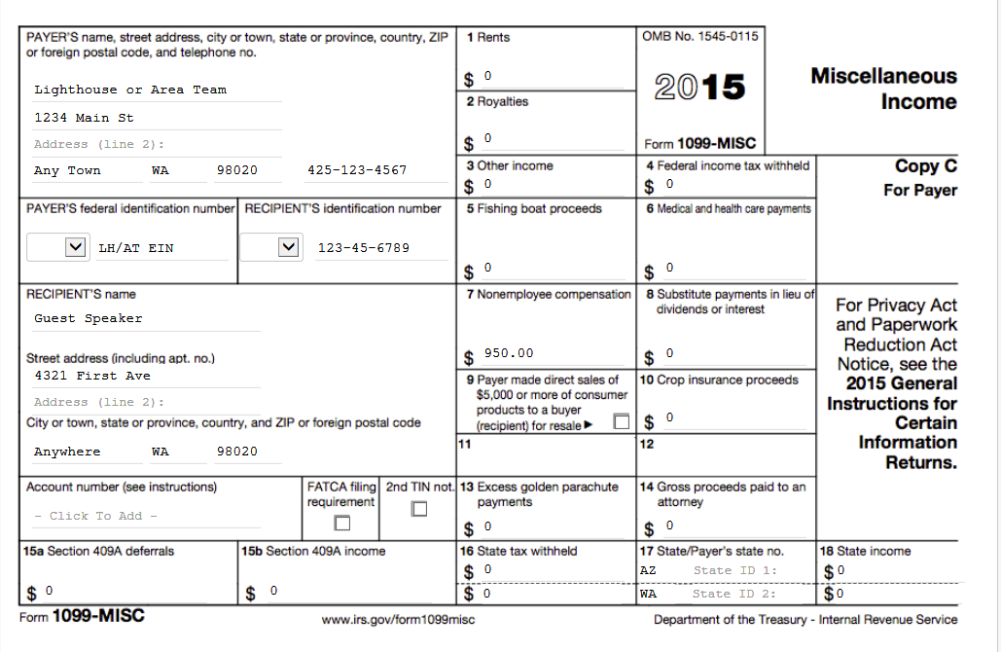

**SAMPLE**

Attention filers of Form 1096:

This form is provided for informational purposes only. It appears in red, similar to the official IRS form. The official printed version of this IRS form is scannable, but a copy, printed from this website, is not. Do not print and file a Form 1096 downloaded from this website; a penalty may be imposed for filing with the IRS information return forms that can’t be scanned. See part O in the current General Instructions for Certain Information Returns, available at www.irs.gov/form1099, for more information about penalties.

To order official IRS information returns, which include a scannable Form 1096 for filing with the IRS, visit [www.IRS.gov/orderforms](http://www.IRS.gov/orderforms). Click on Employer and Information Returns, and we’ll mail you the forms you request and their instructions, as well as any publications you may order.

Information returns may also be filed electronically. To file electronically, you must have software, or a service provider, that will create the file in the proper format. More information can be found at:

* IRS Filing Information Returns Electronically (FIRE) system (visit www.IRS.gov/FIRE), or
* IRS Affordable Care Act Information Returns (AIR) program (visit [www.IRS.gov/AIR](http://www.IRS.gov/AIR)).

See IRS Publications 1141, 1167, and 1179 for more information about printing these tax forms.

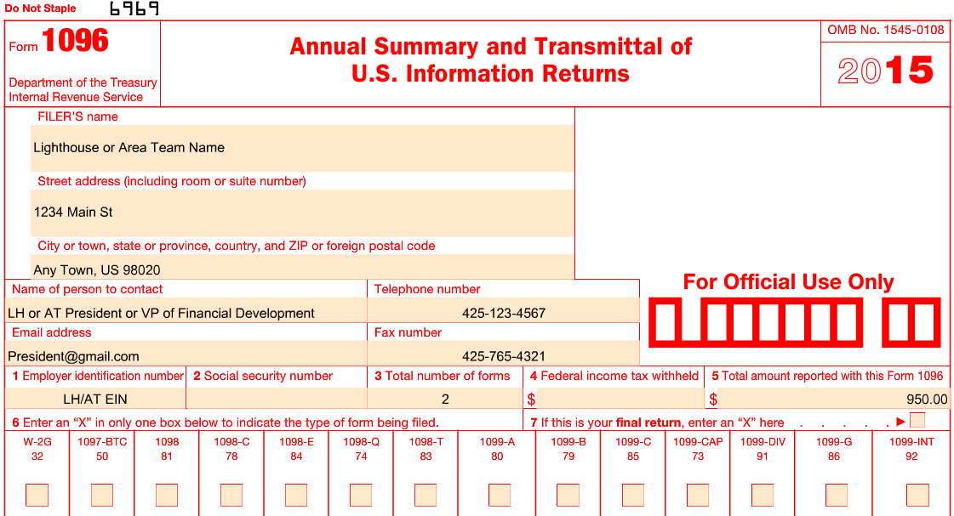

**SAMPLE**

